Name – Gayatri Dnyaneshwar Avhad

Roll no- 231071007

Batch – A

Assignment -3

2

AIM: To write algorithm of linear and binary

search, implemen ng algorithm via program

including google c++ coding style.

THEORY:

1)Linear search :

Linear search, or sequen al search, is a simple

algorithm that checks each element in a list one

by one to find a target value. It doesn’t require the

list to be sorted and is easy to implement.

However, with a me complexity of O(n), it can be

inefficient for large lists, as it may need to

examine every element in the worst case. It's

useful for small or unsorted lists where simplicity

is preferred over speed.

2)Binary search:

Binary search is an efficient algorithm for finding

an element in a sorted list. It works by repeatedly

dividing the search interval in half, comparing the

target value to the middle element. If the target is

less than the middle element, the search

con nues in the lower half; if greater, in the upper

half. With a me complexity of O(log n), binary

search is much faster than linear search for large

datasets. However, it requires the list to be sorted

beforehand, which can add extra overhead if

sor ng is needed.

ALGORITHM: 1)Linear search :

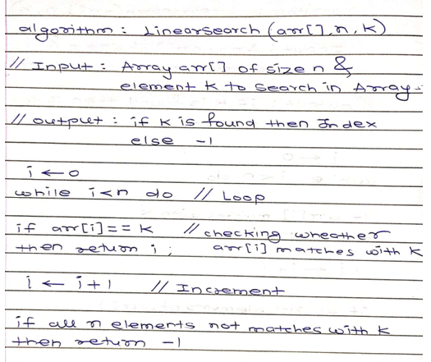

2)Binary search:

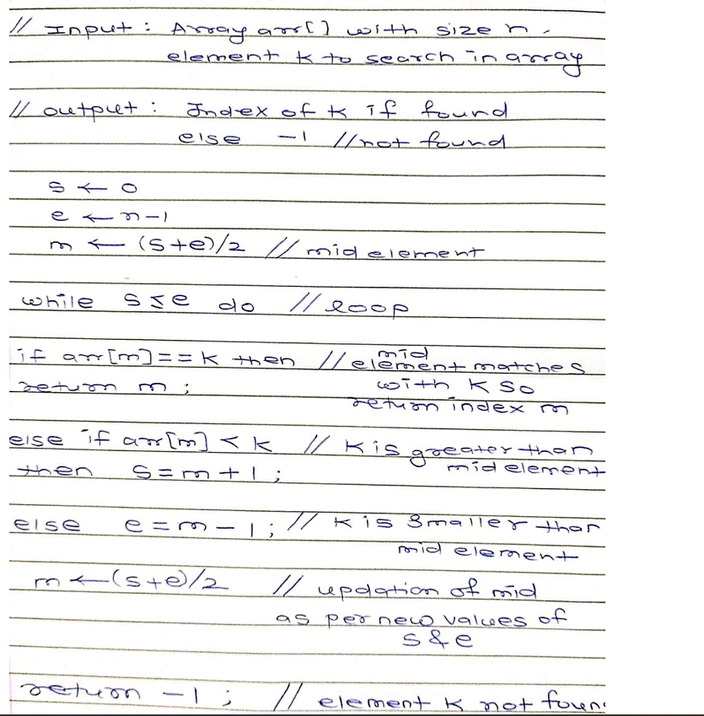

TEST CASES:

1)Linear search:

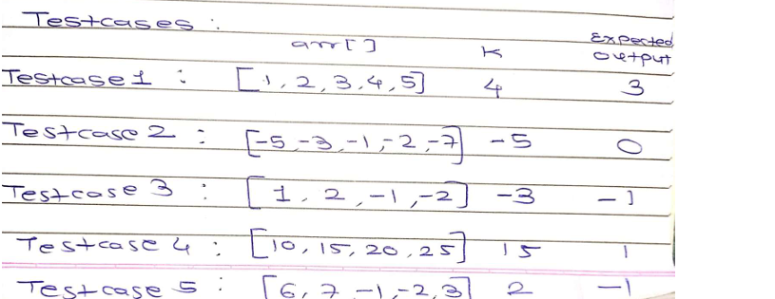

2)Binary search: 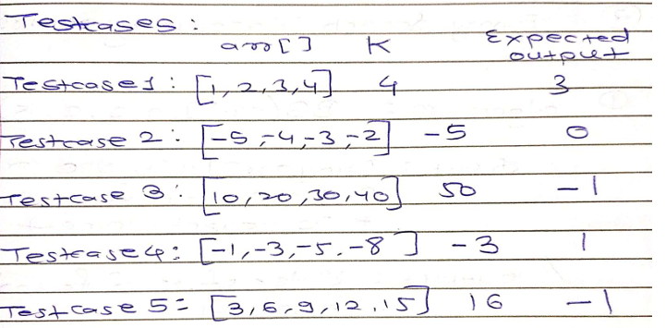

TIME COMPLEXITY :

1)Linear search:

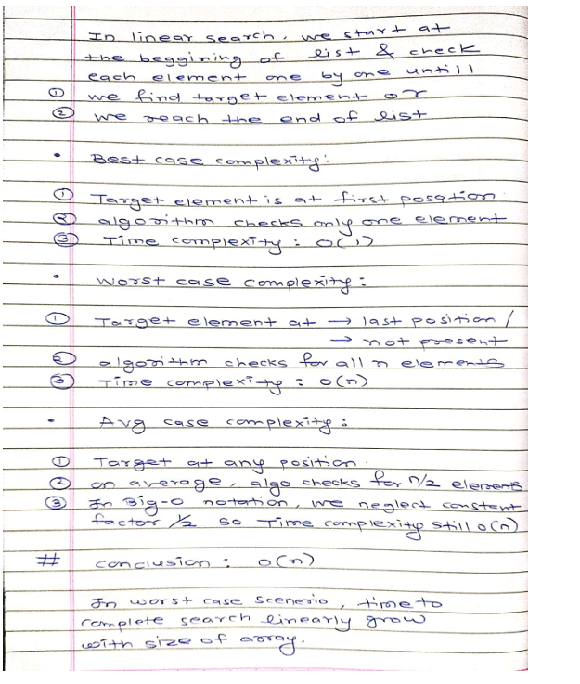

2)Binary search:

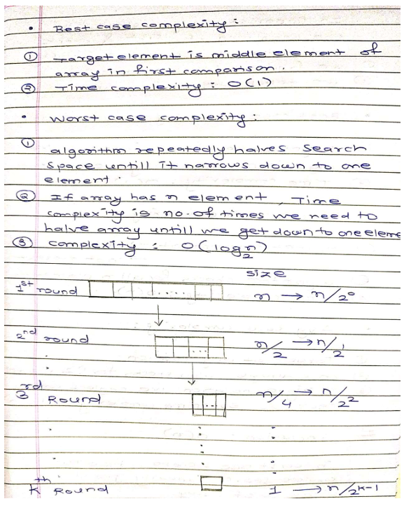

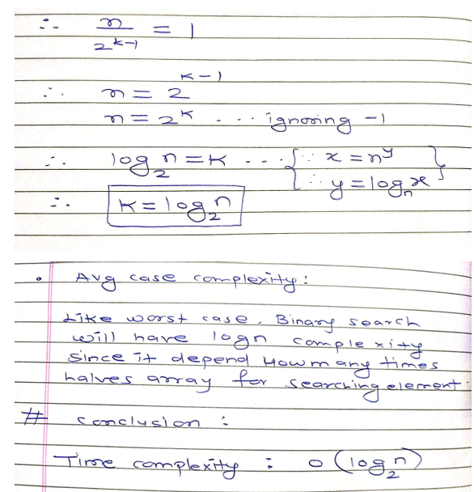

Note: Binary search is more efficient than linear

search because it reduces the search space by half

with each itera on, leading to a me complexity

of (O(log n)) compared to the linear search's

(O(n)).

PROGRAM :

1)Linear search:

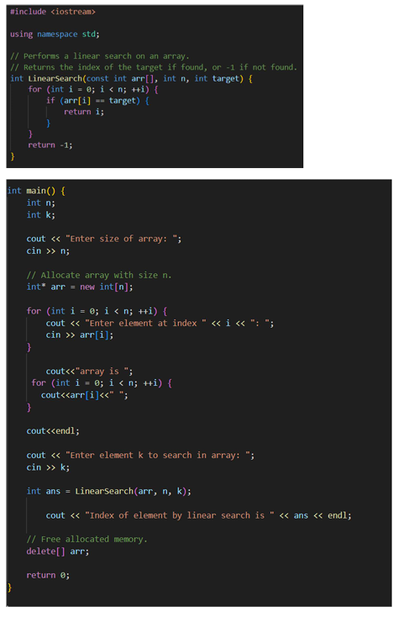

2)Binary search:

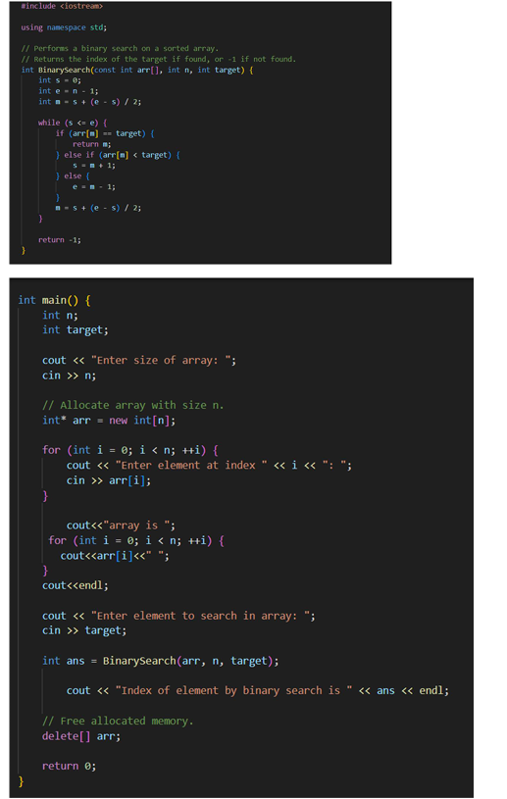

SCREENSHOT:

1)Linear search:

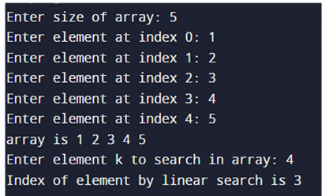

Testcase1:

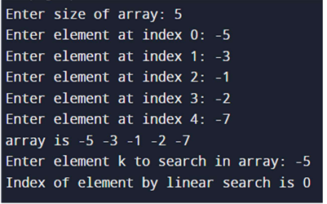

Testcase2:

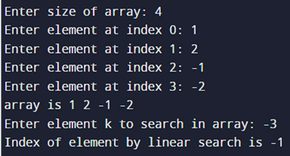

Testcase3:

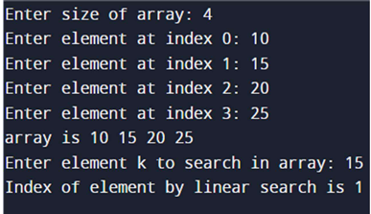

Testcase4:

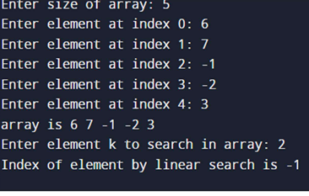

Test case 5



2)Binary search:

Testcase1:

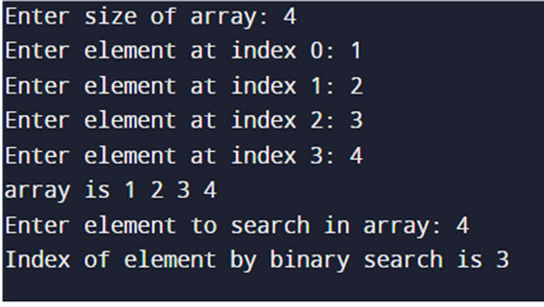

Testcase2:

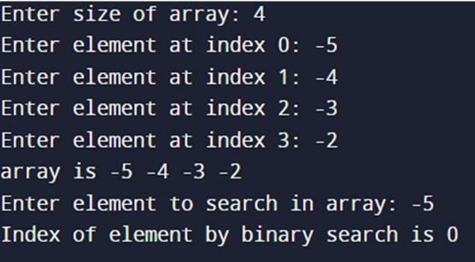

Testcase3:

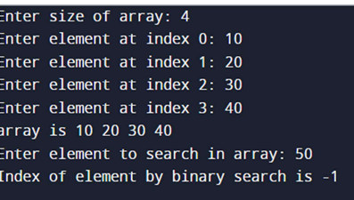

Testcase4:

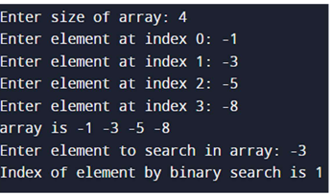

Testcase5:

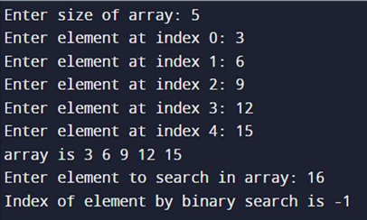

CONCLUSION:

In this way ,we understood algorithm of linear and

binary search and understood how to write code

in google c++ style and we also test 5 testcases

each for linear and binary search and program

output matches with expected output.

We also calculate me complexity of linear and

binary search and concluded that binary search is

more efficient than linear search.

END